Helpful Links
Event Homepage: www.comptia.org/channelcon
Registration Page: https://www.comptia.org/channelcon/register-and-plan/register
Agenda: https://www.comptia.org/channelcon/agenda/daily-agenda
Travel/Hotel: https://www.comptia.org/channelcon/register-and-plan/plan-your-visit

About CompTIA ChannelCon
THE NAME OF THE GAME IN THE BUSINESS OF TECH is turning innovation into realities for your bottom line. Join top tech industry thought-leaders and peers for three inspiring days of vendor-neutral collaboration, learning and partnership. You’ll walk away with a jackpot of new ideas and tools to grow your business and keep our industry at the top of its game.

- Vendor Education
We’ve sweetened the pot for vendors with a specialized mix of education and collaborative sessions offering insight into key trends, business challenges and exciting opportunities in today’s market.

- IT Pro Track powered by AITP
Think ChannelCon isn’t for technical folk? No dice! Bring your tech pros so they can benefit from IT-specific education in sales, customer service and essential soft skills. CompTIA certification holders can also earn CEU credit.

- CompTIA Awards
Help us pay tribute to those making a difference in our industry, from rising stars building careers to well-established leaders with legacies. Nominate your peers, mentors or yourself for a CompTIA Award today!

- Biz Tech
Don’t let the chips fall where they may – take control! Learn new go-to-market strategies in our Biz Tech track that are focused on leading edge technology solutions for your customers and current lines of business.

Who Attends?
ChannelCon 2019 will be held Monday, August 5-7, at the Bellagio Hotel in Las Vegas, N.V. connecting people and companies that are building, selling, influencing and driving the adoption of technology, from traditional and emerging vendors to all types of technology enablers including solution providers, vertical-market specialists and consultants, plus IT pros, media and more.

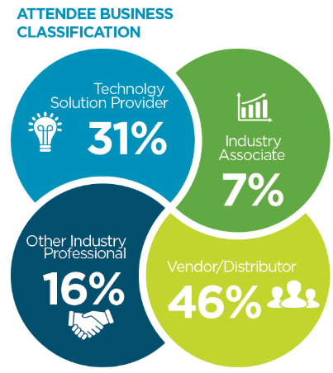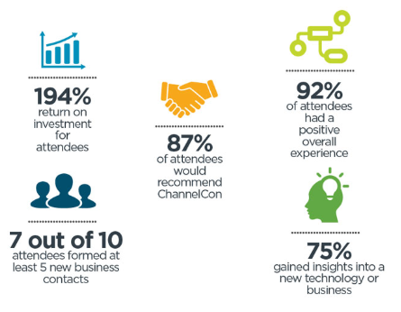

Premier members receive unlimited, free registrations!

Sample Social Media Posts

1. See you Aug. 5-7 at #ChannelCon in Vegas, the premier training, and partnering event for the IT industry. www.comptia.org/channelcon

2. Travel is booked, we’re set for #ChannelCon Aug. 5-7 in Las Vegas, Nevada. Join us for the fun! www.comptia.org/channelcon

3. I’m visiting the city that never sleeps on Aug. 5-7 for #ChannelCon. See you there: www.comptia.org/channelcon

4. I'm heading to the place of dreams and flashing lights! Looking forward to massive networking and educational opportunities at #ChannelCon in Las Vegas Aug. 5-7: www.comptia.org/channelcon

5. Break into new business avenues at #ChannelCon, the can’t-miss event for anyone involved in the business of technology. Register now and join us Aug. 5-7: www.comptia.org/channelcon

6. Form new partnerships and check out the hottest cutting-edge technology at the Technology Vendor Fair #ChannelCon Aug. 5-7 in Vegas: www.comptia.org/channelcon

7. Your IT peers will be in Las Vegas Aug. 5 - Aug. 7 for #ChannelCon – will you? www.comptia.org/channelcon

8. There’s nothing like it for technology leaders: #ChannelCon is coming to Las Vegas Aug. 5-7: www.comptia.org/channelcon

9. No sales pitches from the podium – #ChannelCon is the largest vendor-neutral IT event. Join us Aug. 5-7 in Vegas: www.comptia.org/channelcon

10. We’re exhibiting at #ChannelCon Aug. 5 - Aug. 7 In Las Vegas! Register at no cost as our guest using this VIP code <insert code>.: www.comptia.org/channelcon

