Helpful Links
Event Homepage: www.comptia.org/channelcon
Registration Page: https://www.comptia.org/channelcon/register-and-plan/register
Agenda: https://www.comptia.org/channelcon/agenda/daily-agenda
Travel/Hotel: https://www.comptia.org/channelcon/register-and-plan/plan-your-visit

About CompTIA ChannelCon
The business of technology is changing, and so is ChannelCon. If your business builds, sells, influences or drives the adoption of technology, ChannelCon is the one event you don’t want to miss this year. You’ll not only walk away with new ideas and tools you can immediately put into action, but you’ll find yourself at the epicenter of something big!

- Vendor Education
Exclusive selection of education and collaborative sessions offering insight into key trends, business challenges and exciting opportunities in today’s market.

- IT Pro Track powered by AITP
IT-specific education in sales and customer service for the IT pro, plus essential soft skills. CompTIA certification holders can also earn CEU credit.

- CompTIA Member of the Year
Recognition of a single member who has demonstrated outstanding service and impact through commitment, passion and leadership.

- Biz Tech
Education on go-to-market strategies for companies influencing or driving the adoption of business technologies for your company.

Who Attends?
ChannelCon 2018 will be held Tuesday, July 31 to Thursday, August 2, at the Marriott Wardman Park in Washington, D.C., connecting people and companies who want to bring new and evolving technology business solutions to market including cloud and SaaS offerings, big data and IoT, autonomous vehicles including drones, robotics AI and AR/VR.

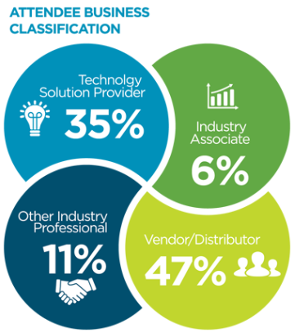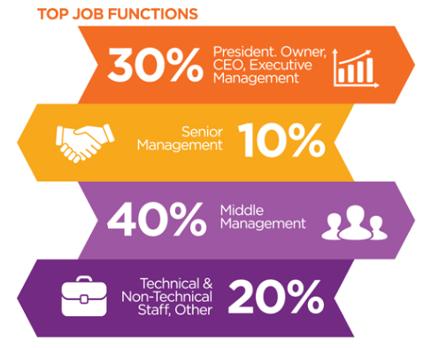

Premier members receive unlimited, free registrations!

Sample Social Media Posts

1. Will we see you at @CompTIA’s #ChannelCon18, the premier training and partnering event for the IT industry? www.comptia.org/channelcon

2. Travel is booked, we’re set for #ChannelCon18 July 31 - Aug. 2 in Washington, D.C. with @CompTIA. Join me! www.comptia.org/channelcon

3. I’m visiting our nation's capital July 31 – Aug. 2 for #ChannelCon18 with @CompTIA. Join me: www.comptia.org/channelcon

4. I'm heading to the place where it happens! Looking forward to massive networking and educational opportunities at #ChannelCon18 in Washington, D.C.: www.comptia.org/channelcon

5. Break into new business avenues at #ChannelCon18: www.comptia.org/channelcon

6. Form new partnerships and check out the hottest cutting edge technology at the Technology Vendor Fair #ChannelCon18: www.comptia.org/channelcon

7. Your IT peers will be in Washington, D.C. July 31 – Aug. 2 for #ChannelCon18 – will you? www.comptia.org/channelcon

8. There’s nothing like it for IT professionals: #ChannelCon18 is coming to Washington, D.C.: www.comptia.org/channelcon

9. No sales pitches from the podium – #ChannelCon18 is the largest vendor-neutral IT event: www.comptia.org/channelcon

10. We’re Exhibiting at #ChannelCon18 July 31- Aug 2. In Washington D.C.! Register at no cost as our guest using this VIP code <insert code>. <insert landing page hyperlink>

